Order Cancel Agreement-PO:GHRC20210721001

Dear Mr. Hayas Shareef,

We are sorry to say that because our customer changed their design, it makes our product not available for the current design. So that means we have to cancel this PO:GHRC20210721001 with payment of ＄19,632. Since we already made the payment to you, so please kindly help us with our cash return request of USD 19,632.00, thanks for your understanding!

Please see the below our bank account information:
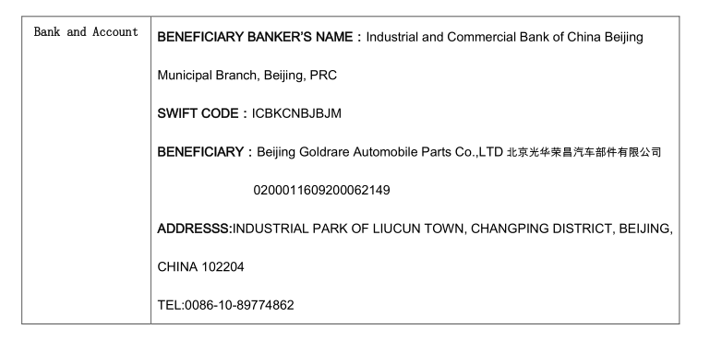

Buyer Seller

Beijing Goldrare Automobile Parts Co.,LTD MCI(Mirror Controls International)BV

Date: 11 February,2022 Date: 11 February,2022

