INFORMATION DOCUMENT
FOR TYPE APPROVAL OF A DEVICE FOR INDIRECT VISION
UN REGULATION No. 46, Amend. 05, Suppl. 0
1. Make (trade name of manufacturer) |  | : |   GOLDRARE;
2. Type and general commercial description(s) |  | : | ISTYPJ01
3. Means of identification of the type, if indicated on the device |  | : | ISTYPJ01
4. Category of vehicle for which the device is intended |  | : | M1
5. Name and address of manufacturer |  | : | Beijing GOLDRARE Automobile Parts Co., Ltd.  Room 101, 1-3 Floor, Building 9, Yard No.600,  Beiliu Village, Changping District,  102204 BEIJING,  China (PRC)
5.1. Name and address of manufacturer's representative |  | : | Not applicable
6. Location and method of affixing of the approval mark |  | : | Molded on the housing
6.1. Other mean of identification link to the approval mark |  | : | Not applicable
7. Address(es) of assembly plant(s) |  | : | Hebei GOLDRARE Automobile Parts Co., Ltd.  No. 150 Taishan Road,  Huanghua Economic Development Zone,  061100 Huanghua City, Hebei Province,  China (PRC)
8. Mirrors (state for each mirror):
 | Class | : | I
 | General description | : | Interior mirror mounted on the windshield
 | Mounting method | : | Clip
 | Radius of curvature | : | Flat (r=∞)
 | Main dimensions | : | Width: 242.2 mm, height: 62.1 mm
 | Tinting of mirror | : | no
 | Reflective coating of mirror | : | silvering
 | Mirror housing material | : | PC+ASA
 | Reflecting surface adjusting system | : | Manual
8.1.Variant |  | : | Not applicable
8.2. Drawing(s) for the identification of the mirror |  | : | Refer to page 5
8.3. Details of the method of attachment |  | : | Refer to page 3-6
9. Devices for indirect vision other than mirrors |  | : | Not applicable
This information document consists of 6 pages

1) cross-out where not applicable
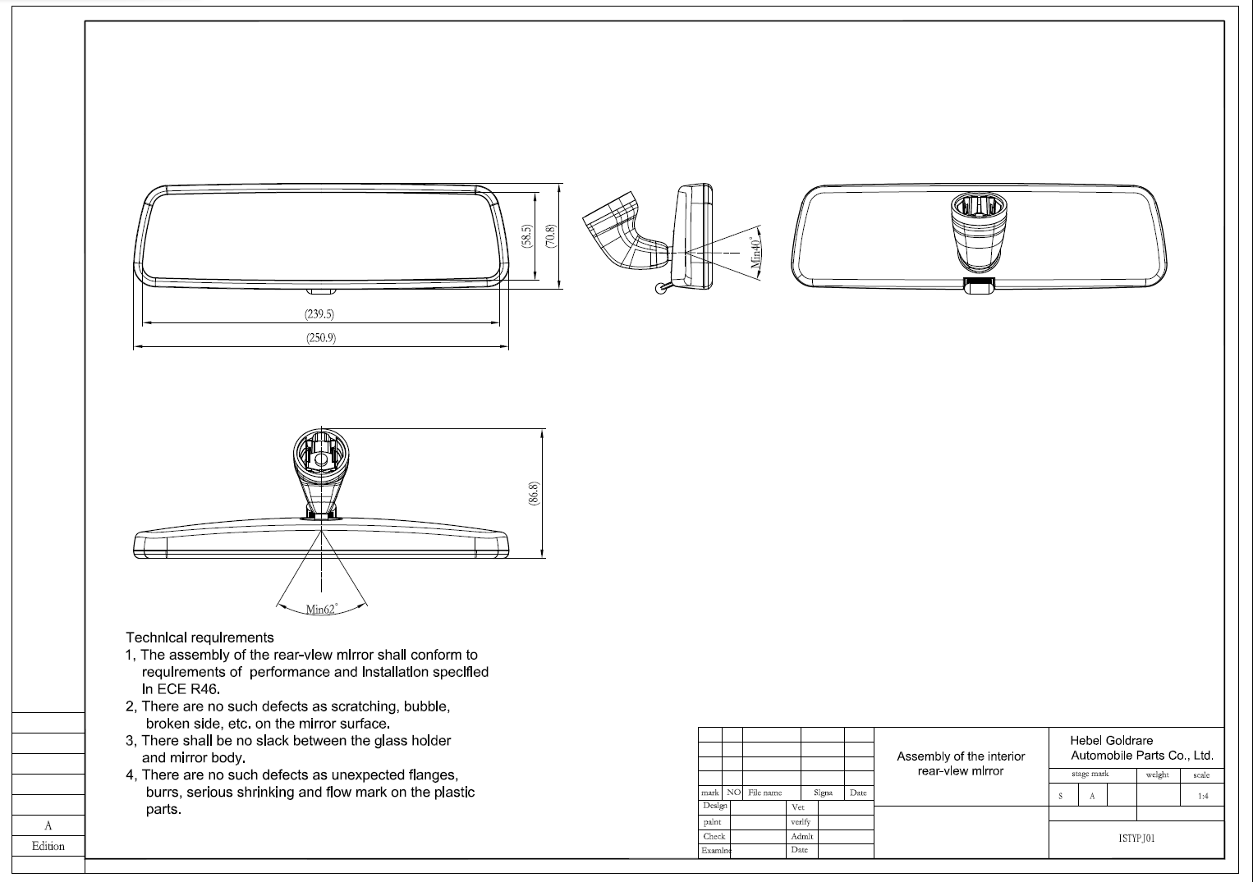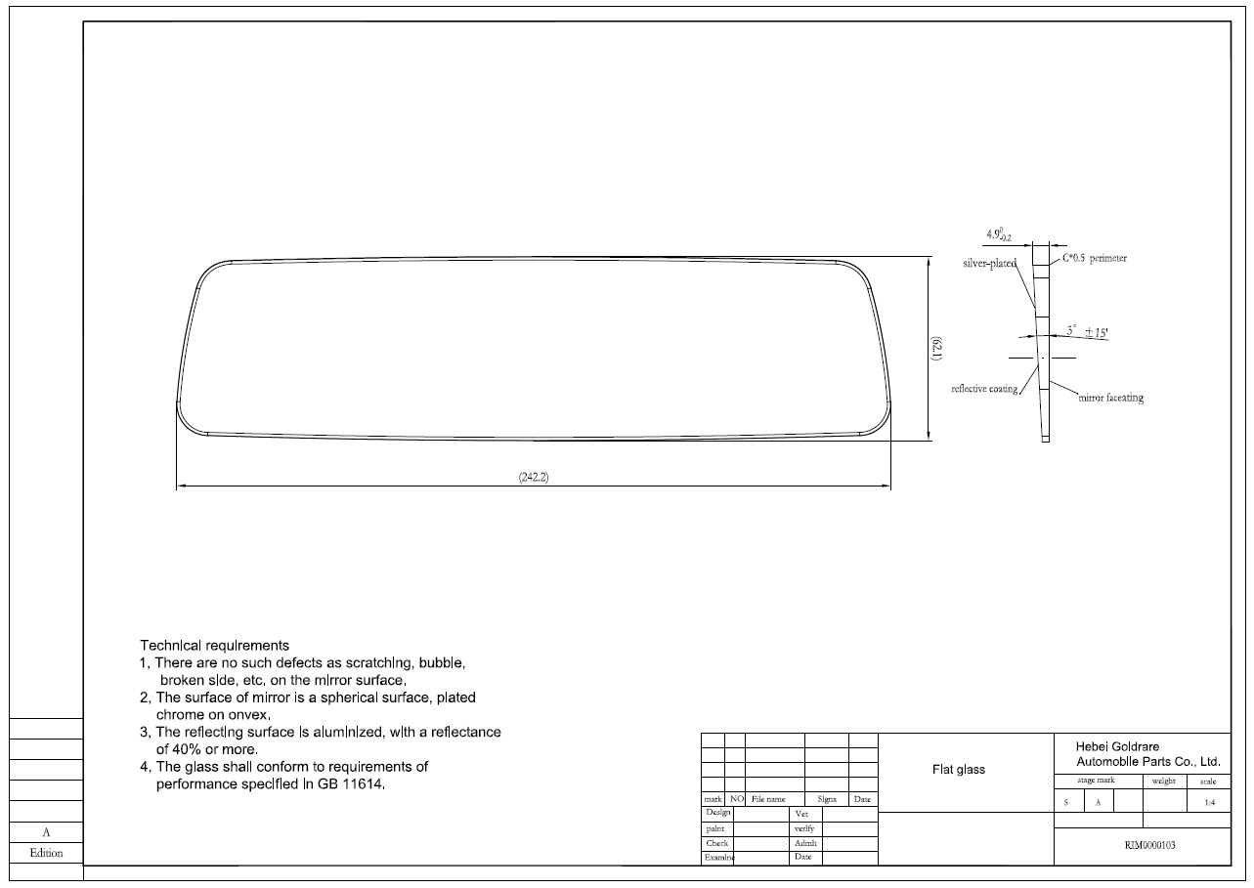
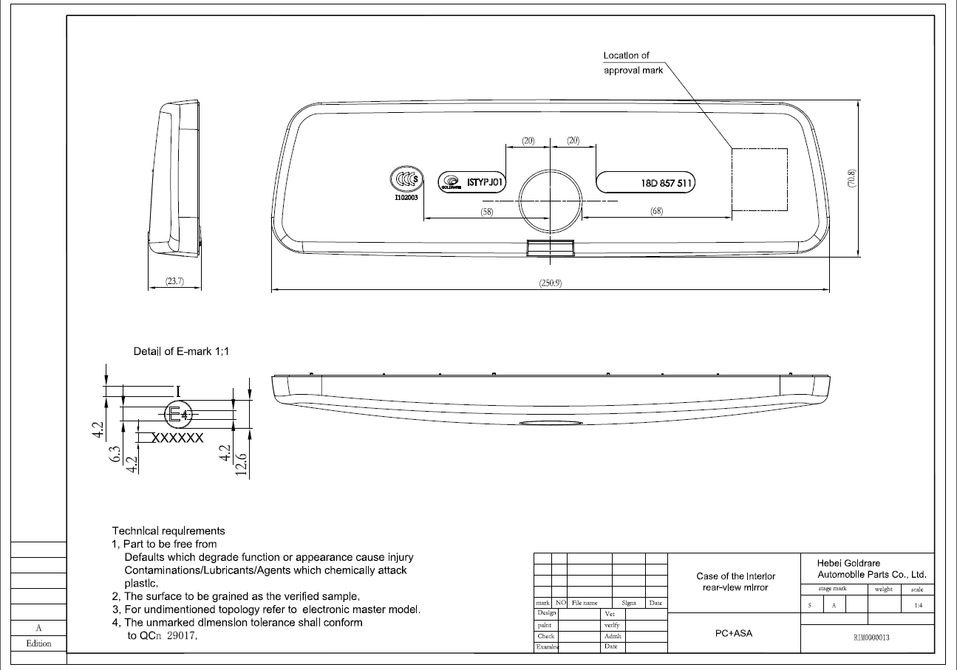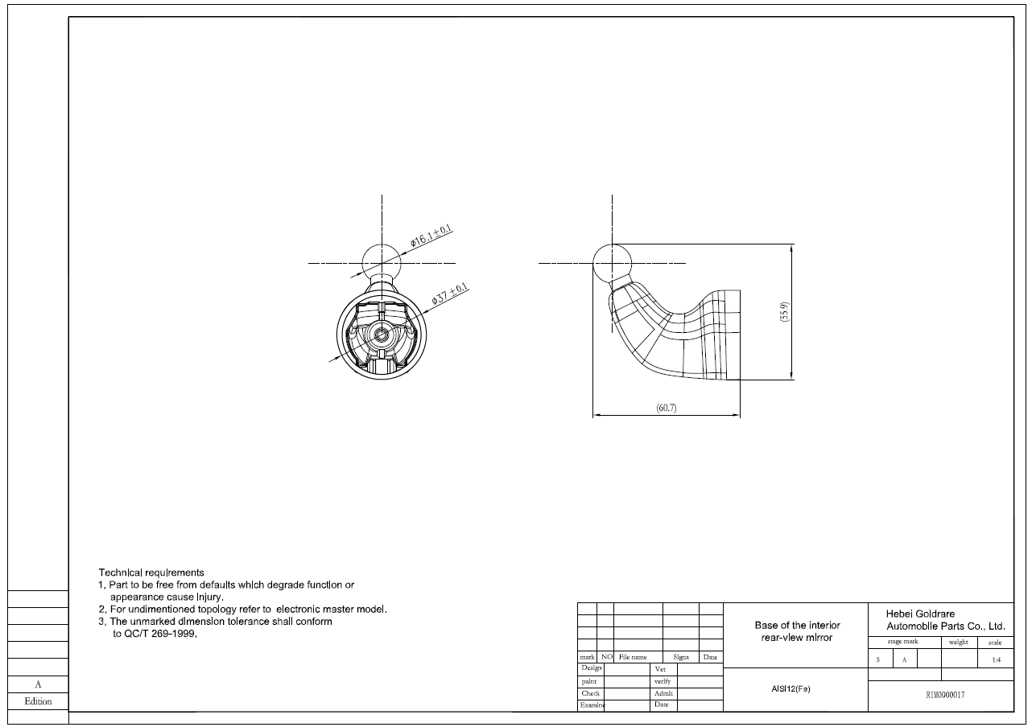

Statement Concerning Resistance to Corrosion and Aging

We, Beijing GOLDRARE Automobile Parts Co., Ltd. herein guarantee that reflecting surface of rear-view mirror of the following type(s):
Type: ISTYPJ01
will retrain the characteristics specified in UN Regulation No. 46.05 in spite of prolonged exposure to adverse weather conditions, in normal condition of use.

Dated: August 23, 2024

Yours faithfully,

Name: Xia Yongfei/ Quality Manager
Beijing Goldrare Automobile Parts Co., Ltd.

