DENGINFORMATION DOCUMENT
FOR TYPE APPROVAL OF A DEVICE FOR INDIRECT VISION
UN REGULATION No. 46, Amend. 06, Suppl. 1 ANNEX 1
1. Make (trade name of manufacturer) |  |  |  | : |   GOLDRARE;
2. Type and general commercial description(s) |  |  |  | : | FMD&FH-005
3. Means of identification of the type, if indicated on the device |  |  |  | : | Not applicable
4. Category of vehicle for which the device is intended |  |  |  | : | N3
5. Name and address of manufacturer |  |  |  | : | Beijing GOLDRARE Automobile Parts Co., Ltd.  Room 101, 1-3 Floor, Building 9, Yard No.600,  Beiliu Village, Changping District,  102204 BEIJING,  China (PRC)
5.1. Name and address of manufacturer's representative |  |  |  | : | Not applicable
6. Location and method of affixing of the approval mark |  |  |  | : | molded to the housing.
6.1. Other mean of identification link to the approval mark |  |  |  | : | Not applicable
7. Address(es) of assembly plant(s) |  |  |  | : | Hebei GOLDRARE Automobile Parts Co., Ltd.  No. 150 Taishan Road,  Huanghua Economic Development Zone,  061100 Huanghua City, Hebei Province,  China (PRC)
8. Mirrors (state for each mirror):
 | Class |  |  | : | IV
 | General description |  |  | : | Wide-angle view mirror mounted on the vehicle door of driver side or passenger side
 | Installation angle with respect to median horizontal plane of vehicle |  |  | : | Driver side: , Passenger side:
 | Mounting method |  |  | : | Screw fixation
 | Radius of curvature |  |  | : | R = 300+40mm
 | Main dimensions  Reflective coating of mirror |  |  | :  : | Width: 193 mm, height: 183 mm  Chrome
 | Mirror housing material |  |  | : | ASA
8.1.Variant |  |  |  | : | 78807042(REM0010843)  78807043(REM0010845)  78807044(REM0010844)  78807045(REM0010846)
8.2. Drawing(s) for the identification of the mirror |  |  |  | : | Refer to the drawings of this information folder
8.3. Details of the method of attachment |  |  |  | : | Refer to the drawings of this information folder
Variant |  | Mirror surface adjustment | Folding system |  |  | Side direction indicator | Remark
78807042(REM0010843) |  | YES | Manual operation |  |  | Not applicable | Left installation angle 8 degrees
78807043(REM0010845) |  | YES | Manual operation |  |  | Not applicable | Symmetrical with 78807042(REM0010843)
78807044(REM0010844) |  | YES | Manual operation |  |  | Not applicable | Symmetrical installation angle difference of 4 degrees with 78807042(REM0010843)
78807045(REM0010846) |  | YES | Manual operation |  |  | Not applicable | Installed on the same side as 78807042(REM0010843) but with an angle difference of 4 degrees
9. Devices for indirect vision other than mirrors |  |  |  | : | Not applicable
This information document consists of 11 pages
1) cross-out where not applicable

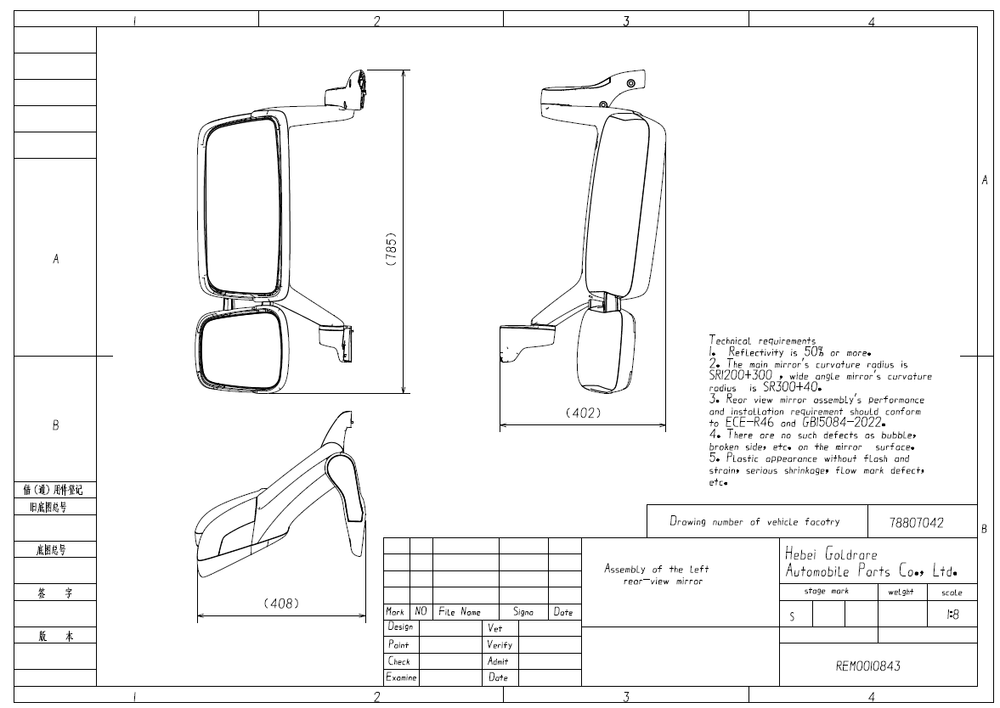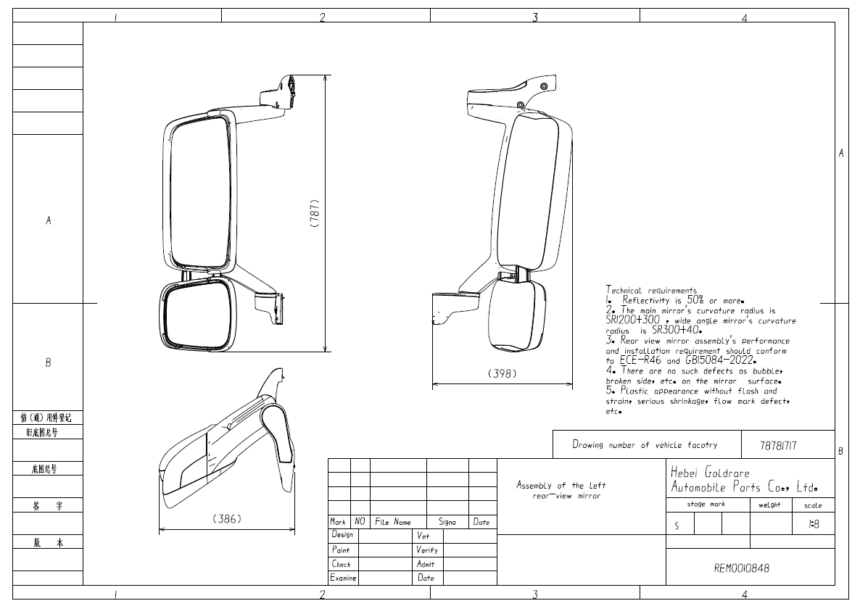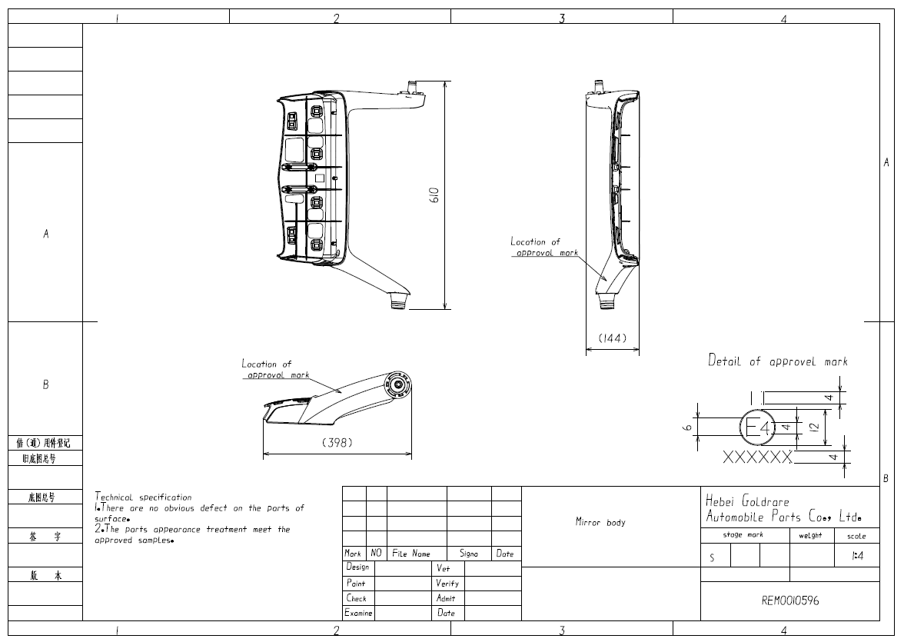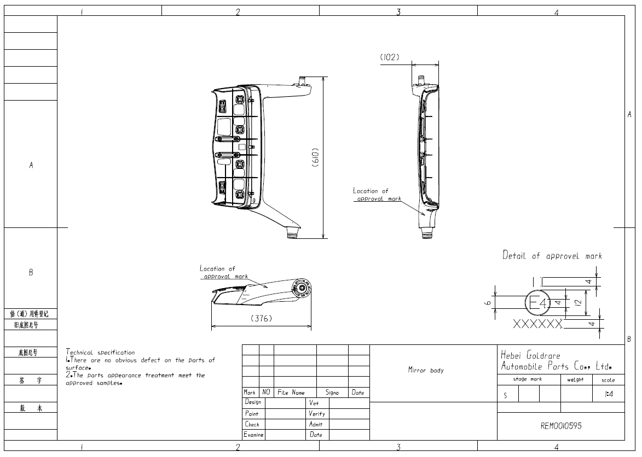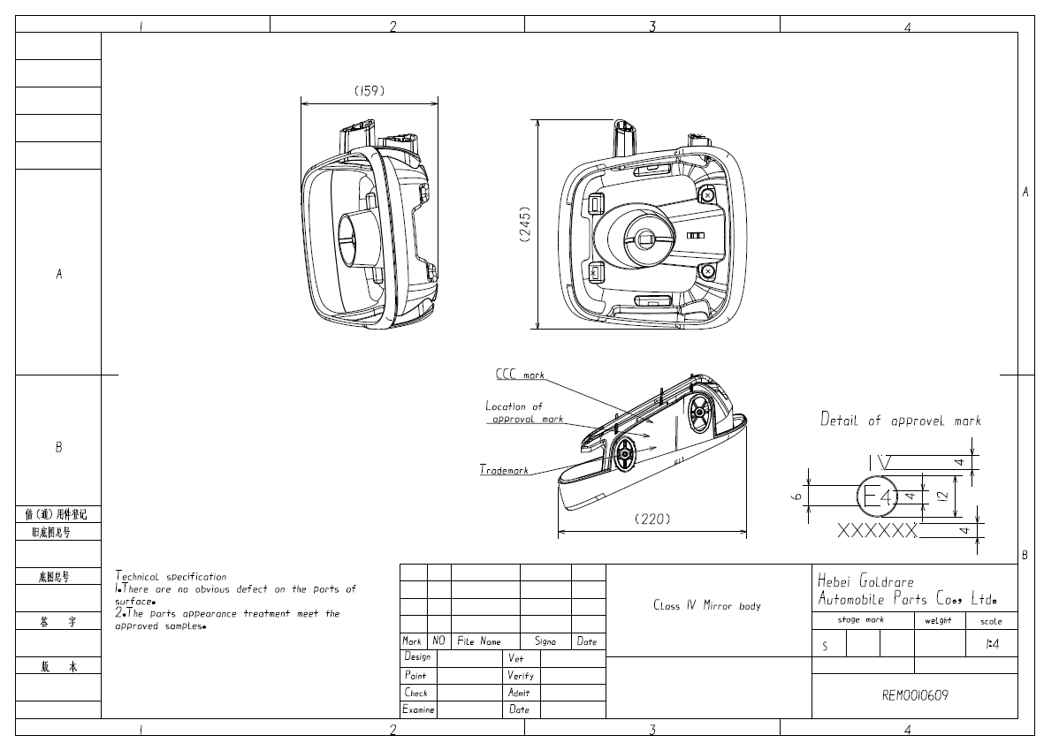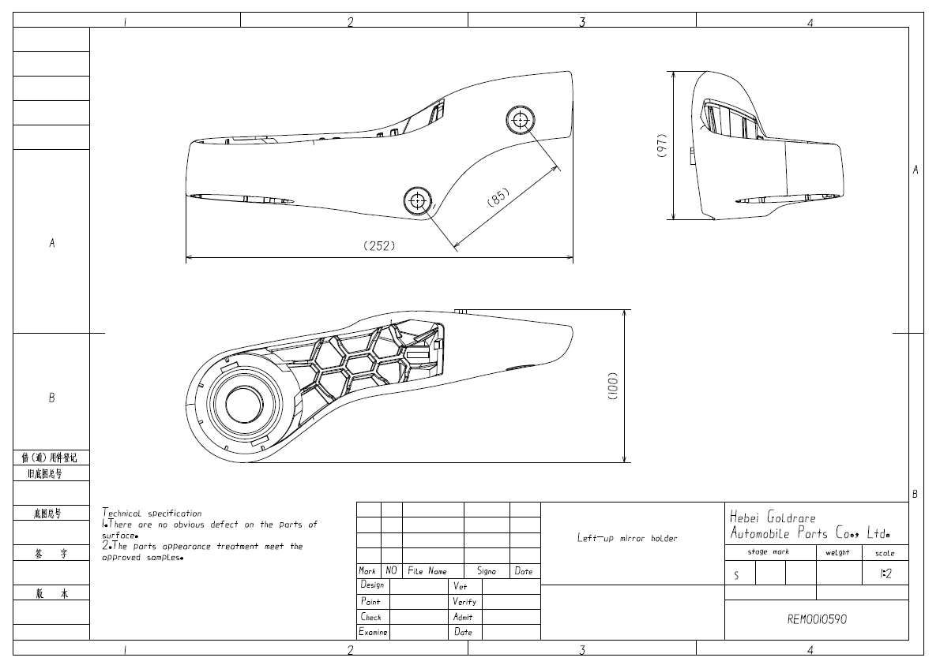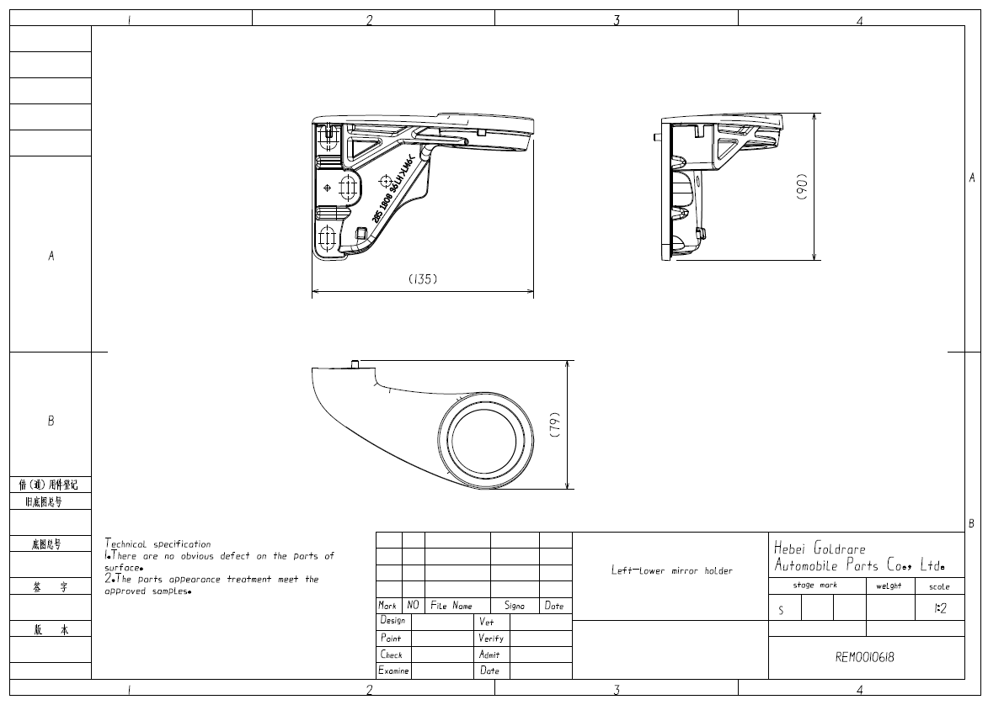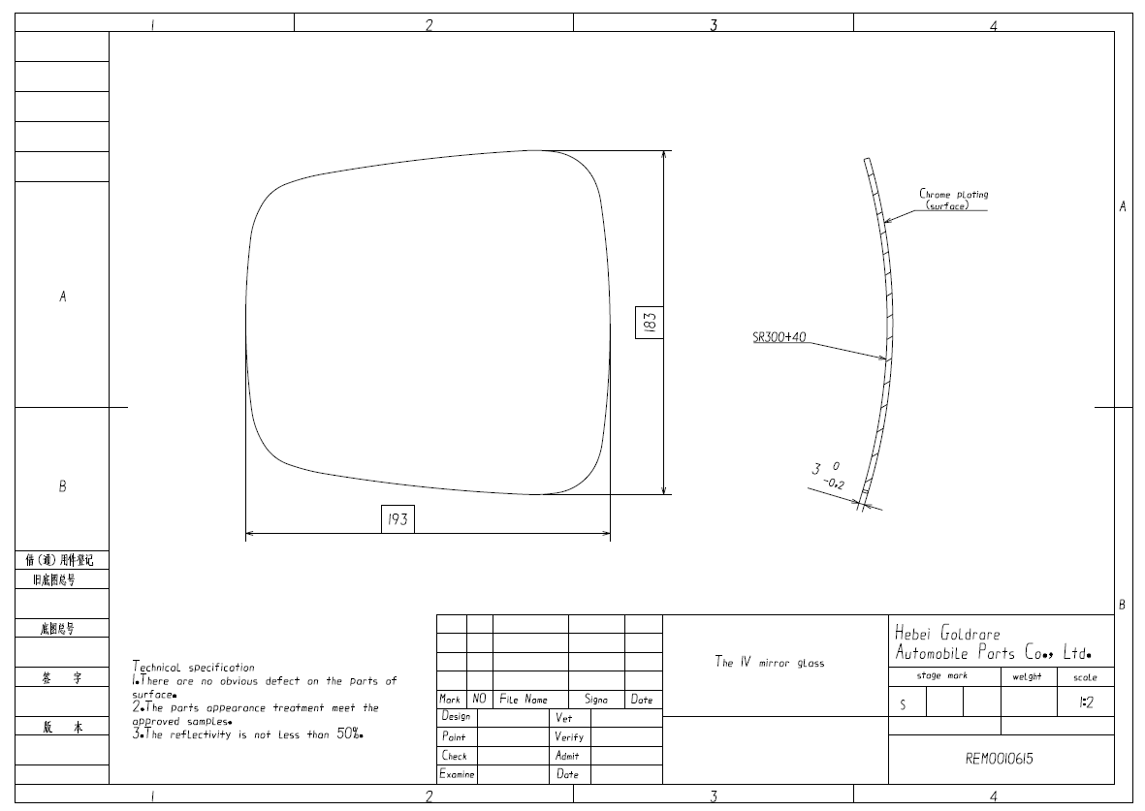
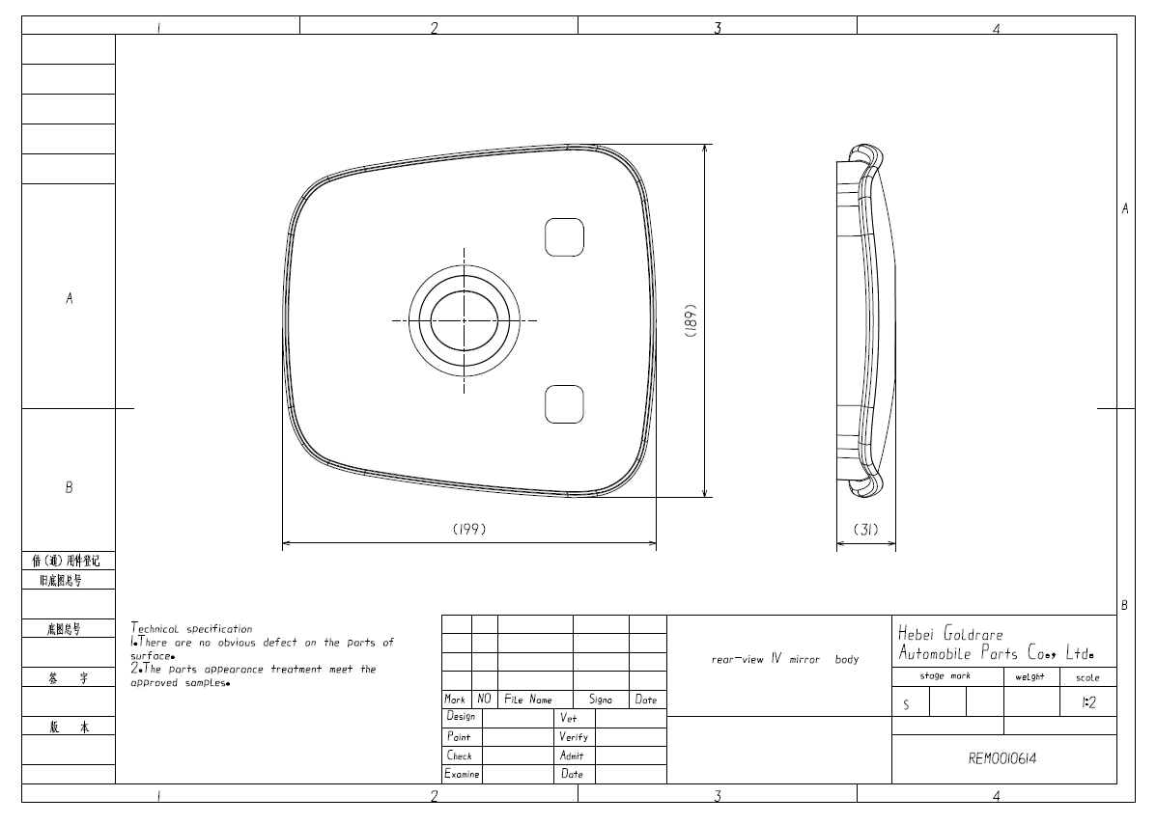

Statement Concerning Resistance to Corrosion and Aging

We, Beijing GOLDRARE Automobile Parts Co., Ltd.
herein guarantee that reflecting surface of rear-view mirror of the following type(s):
Type: FMD&FH-005
will retrain the characteristics specified in UN Regulation No. 46.06 in spite of prolonged exposure to adverse weather conditions, in normal condition of use.

Dated: September 09, 2025

Yours faithfully,

Name: xiayongfei/ Manager
Beijing Goldrare Automobile Parts Co., Ltd.

